BIOGRAPHICAL SKETCH

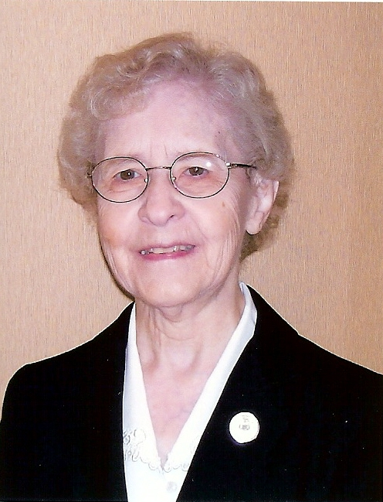

Sister Pauline Lamirande
(Sister St. Yolande of Jesus)

July 21, 1924 - January 14, 2015

“What no one ever saw or heard,
What no one ever thought could happen,
Is the very thing God prepared for those who love Him.”
(1st Corinthians 2:9)

Sister Pauline Lamirande, formerly known as Sister St. Yolande of Jesus, was born on July 31, 1924, in Biddeford, Maine. Her father, William Lamirande, was born in Rivière-du-Loup, Québec, Canada. Her mother, Emma Vallière, was born in Biddeford, Maine. Her father was a machinist by trade and her mother was a housewife. Pauline was the third oldest in a family of six children. She received her education in the schools of St. Joseph Parish in Biddeford and was taught by the Good Shepherd Sisters.

Sister Pauline shared that she had a very happy family life. Her father, she stated, was a “jolly man” who played with us children and enjoyed sports. Every New Year’s Day, they had a large family reunion at Pepère Valière’s home that was attended by all the Valières of their family. Everyone asked their grandfather for a blessing at this gathering. The family prayed the rosary every evening and had a great devotion to the Blessed Virgin Mary.

Pauline enjoyed sitting beside the radio next to her dear father, who was an avid sports fan, listening to the Boston Red Sox games and the Boston Patriots football games. This naturally quiet, timid, little girl suddenly became a very excited little cheer leader. This love of sports was a favorite pastime all her life.

Two of her mother’s sisters, Laura and Diana Valière had entered the Good Shepherd Sisters. Pauline’s two older sisters, Marcelle and Rita, also joined the Good Shepherd Sisters in Biddeford.

With so many of the family finding happiness in religious life, Pauline also felt that God was inviting her to join the community. On August 25, 1940, at the age of sixteen, Pauline entered the Congregation of the Sisters of the Immaculate Heart of Mary in Biddeford, Maine. The group of fourteen postulants added to the number of novices swelled the ranks to thirty-three in the novitiate. Her first profession was at the small chapel of 69 Adams Street. Due to lack of space, benches were installed outside on the grounds close to the chapel windows.

Pauline began piano lessons in third grade and continued her lessons throughout her school years. She received her high school diploma from American School in 1943 as a junior professed sister. She was affiliated with Laval University through her teachers, Sister Marie-Elizabeth (Beatrice Couillard) and Sister Marie-Virginie (Corinne Fiset) whom she held in very high esteem. In 1951, Sister Pauline received her Teacher’s Certificate from Sherwood Music School.

Sister taught piano lessons and directed choirs in Maine and Massachusetts for twenty-two years. She also taught elementary school for twenty-one years in Lawrence, Massachusetts. Her family moved to Lawrence upon her father’s retirement. She taught in the elementary school in Old Town, Maine for six years and was greatly loved and appreciated by the parishioners. She shared her gift of music in the Community for over seventy years as an accomplished musician on both piano and organ, and as choir director.

While she was stationed in Lawrence, a neighboring school in Methuen, St. Monica School, organized an area children’s choir with Sister Pauline as choir director. It was while students were at a practice that Sister Pauline discovered a talented fifth grade student, Andrew Scanlon, who strolled to the organ and with her permission began to play. He had taken piano lessons for a year, but had never tried the organ. Pauline was instrumental in his introduction to the organ and he progressed as only a prodigy can. He remains most grateful to Sister Pauline and is now an accomplished organist in South Carolina holding degrees in music, teaching on a college level and giving lessons to students. How honored Sister Pauline was to have Andrew play at the Funeral Mass of her dear mother in Lawrence, Massachusetts.

At Sister Pauline’s Golden Jubilee celebration, the Sisters composed the following acronym:
P RAYERFUL; ever PRAISING the LORD in SONG

A CHIEVER; AMIABLE

U NASSUMING; UNDERSTANDING

L OVING TO ALL

I NFINITELY PATIENT; INTERESTED in OTHERS

NEAT; NICE CONTINUALLY

EFFICIENT; EVER READY TO HELP OTHERS

They added that the name Pauline is the feminine of Paul which is of Latin origin and means HUMBLE or LITTLE. These qualities aptly describe Sister Pauline.

In 1991 when St. Anne Parish and School closed in Lawrence, Massachusetts, Sister Pauline was transferred to our Bay View Convent where she was organist and choir director until her transfer to St. Joseph Convent in 2008. She was very active while at Bay View contributing hand knit items to be sold at the gift shop. Both she and her dear friend, Sister Marie-Paule Sirois remained avid sports fans, keeping their hands busy with knitting during the games. Though crippling arthritis caused great pain in her hands, Pauline continued playing music and knitting for the gift shop as long as humanly possible.

Pauline also had a quiet apostolate of corresponding with friends and others in need whom she had met along the way. She was faithful to send greeting cards to them and drop them a line when appropriate. She frequently phoned her sister Rita in New Hampshire and even arranged to visit with her a few days a year to help her out. She also visited some of Rita’s neighbors in her apartment complex on these occasions.

When Bay View was in the process of closing, Sister transferred to Good Shepherd Pavilion. She became the organist and choir director at St. Joseph Convent. Her loving heart was wearing out, but her courage never failed her. Even after a stroke in December which affected one hand, she managed to play two hymns on the organ at the Christmas Liturgy. In the words of St. Exupery: “It is only with the heart that one can see rightly; what is essential is invisible to the eye…” Sister Pauline, who was humble and little in stature, was truly a giant in reality who gave her life to God, her Community and her friends to the day her loving heart could beat no more on earth and joined the Lord and “her dear Blessed Mother” in heaven.

One great weight Pauline carried all her life was a phobia for viewing a deceased person. How she prayed to her mother when she died to remove this from her. Pauline’s wish was not to be granted until a few days before her own death when she had a dream and her “dear Blessed Mother” came to her and assured her that she had nothing to fear that she would be with her when she died and would guide her safely to her Beloved Spouse in heaven. This dream she shared with her caretakers and her last days and hours were quiet and peaceful from that night on.

Sister Pauline is survived by one sister, Rita Hammer of Rochester, New Hampshire and one brother, Robert Lamirande of Salem, New Hampshire, and several nieces and nephews and friends.

Her Mass of Christian Burial was celebrated at St. Joseph Convent on Friday, January 16, 2015. Her burial was at St. Joseph Cemetery, Biddeford, Maine.

Officiating at Mass was her cousin, Reverend Father Emile H. Dube, Parochial Vicar of St. Joseph Parish, Ellsworth, Maine.

In his homily, Father Dube shared the following reflections:

In the Gospel of Matthew, I can see Jesus standing by the pearly gates, and the Lord with arms open wide telling Sister Pauline, “Come to me, you who labor and are burdened and I will give you rest. Take my yoke upon you and learn from me, for I am meek and humble of heart; and you will find rest now, Pauline, for yourself, for my yoke is easy and my burden light.” In other words, Pauline, have no more fear of dying—for you are now in my embrace.

I have heard Sister Pauline described as a meek and humble person. She touched many people with her kindness and meekness. Of course, the only time she was not meek was when she watched the Red Sox or Patriots play. That meekness went right out the window during the games.

I lost contact with Sister Pauline for several years. When I became a seminarian for the priesthood seven years ago and was assigned to Biddeford, I inquired about my cousins of the Lamirande family. That is when I found that it was just Sister Pauline who was left in the area. So, we reconnected after forty-five years and I can truly say that it was part of God’s plan, because I feel very strongly that as I stand here today as an ordained priest that it is because of the prayers of Sister Pauline and the prayers of this community. There were times that I was doubting and struggling in the seminary, but I could always feel that source of strength and courage coming from somewhere.

Eternal rest and peace to you, Cousin Pauline, and let perpetual light shine upon you. May you rest in peace. Amen.

Sister Sharon Leavitt, S.C.I.M.

Feast of the Presentation of Jesus
February 2, 2015

